Comments from 18.08.2025

1. Tested heating data.

File: [heating_data.xlsx](https://tripleiio-my.sharepoint.com/:x:/g/personal/dev_triplei_io/EbQXBlJO9oRNpQMpx7HQbIsBw1q2KpwotFhv31Y2jqeP-w?e=JHluxO)

* D_country:

three fields were empty

* DE1_ActivityEmissionSource

* DE1_Unit

This table was empty, whereas AI needed to populate it with the units related to heating (cubic meters; ID = 12)

* D_Currency

This was also empty although it should have been Euro since we have a column in the source data called “Paid_EUR”

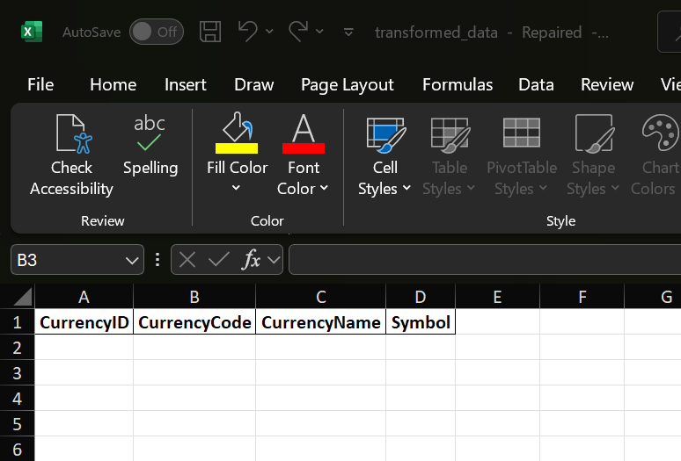

* FE1_EmissionActivityData

1. Some fields are empty (because their corresponding dimension tables are also empty as mentioned above)

1. EmissionFactorID-s are not as described in the task

1. Tested electricty data.

File: [electricity_data.xlsx](https://tripleiio-my.sharepoint.com/:x:/g/personal/dev_triplei_io/EZr4un9qk5JMrVTjVurFrswBKm0DRO--v1txQovGQjY4eg?e=S0NiZB)

* DE1_ActivityEmissionSource

Here we needed to see ONLY Emission Sources related to category electricity (**ActivitySubcategoryID =**21)

* D_Currency

This was again empty although it should have been Euro since we have a column in the source data called “**TotalPaidEUR**”

* DE1_ActivityEmissionSourceProvider

This table was empty. AI did not populate this table with proper data

* FE1_EmissionActivityData

1. EmissionFactorID: this had the same issue as above

1. ActivityEmissionSourceProviderID: this field had the ID value 1, although the dimension table was empty/not populated (as mentioned above)

1. Some empty fields

